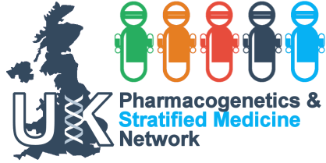

**Autumn Workshop 23rd October 2014**

**Defining Drug Response for Stratified Medicine**

**The University of Liverpool in London  
33 Finsbury Square, London, EC2A 1AG**

**Programme**

**9.30-9.55** Registration and Refreshments

**9.55-10.00** Prof Munir Pirmohamed: Welcome and Plan for the Day

**10.00-10.45** Prof Stephen Senn: Variability in drug response

**10.45-11.30** Prof Andrew Hattersley: Defining efficacy in drug response

**11.30-12.15** Prof Munir Pirmohamed: Defining safety in drug response

**12.15-12.30** Discussion

**12.30-13.30** Lunch

**13.30-15.00** Discussion groups:

Delegates split into groups of 10 with a rapporteur to discuss the 3 topics

**15.00-15.20** Coffee

**15.20-16.00** Report from breakout groups and final discussion

**16.00** Close of meeting and action plan

***Delegates will be invited on a first come, first served basis. The event is free of charge but unfortunately we will not be able to cover expenses.***

***Please contact Christine McNamee*** [***cjmcn@liv.ac.uk***](mailto:cjmcn@liv.ac.uk) ***to register***